Using jQuery with JSON and API’s
For this lab we will create a single page application using Bootstrap, jQuery, JSON and the YouTube API.

Step 1:
Source a Bootstrap theme to use for your video player application.
Try http://startbootstrap.com/ to see if there is a free theme you like. Find one and download it. If it is a zip extract it to your laptop. For this example the lab will use the Business Casual theme from http://startbootstrap.com/template-categories/all/.

Step 2:
Create a new project folder on your local web server named videoplayer

Step 3:
Add the content from the bootstrap theme to the new videoplayer folder. The folder should now look as follows:
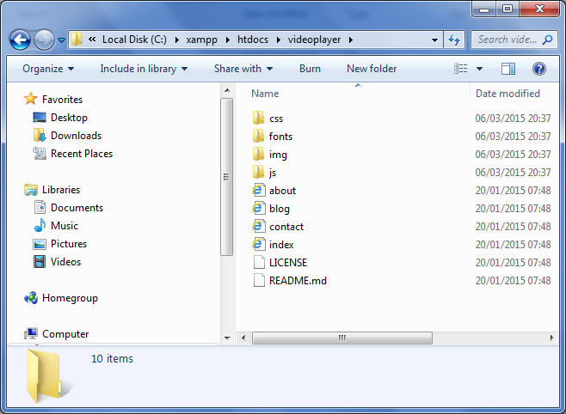

Step 4:
The main page that will be used for the single page application will be index.html

Step 5:
Open the index.html page in a browser to see what the Bootstrap theme looks like.
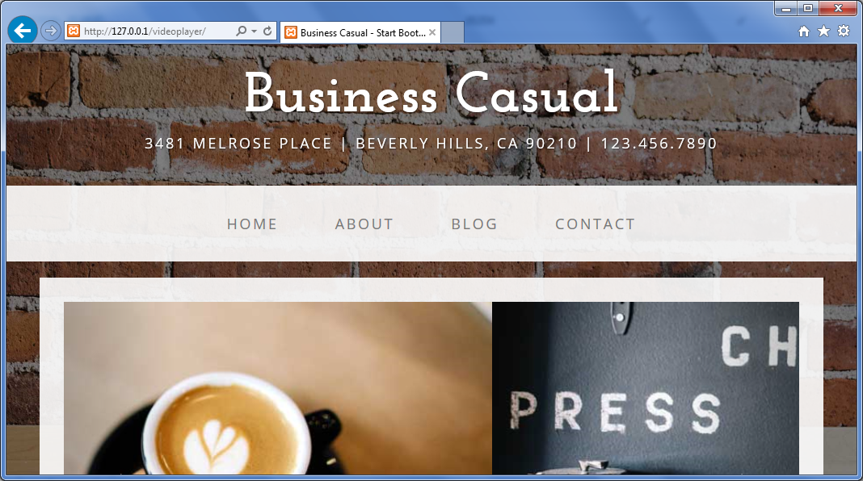

Step 6:
Add a file name site.js to the js folder
Add the following to the file:
console.log('Custom JS file added');

The file should look as follows:
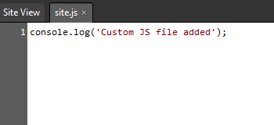

Step 7:
Add a file named site.css to the css folder

Step 8:
Open index.html for editing
Add the site.css file to the page
The css should be added to the head section of the page and should look as follows:
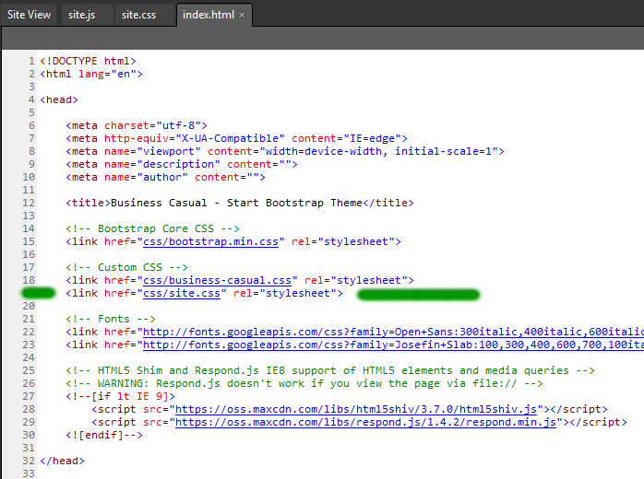
The new addition is marked with the green line.

Step 9:
Add the site.js file to the page
The js should be added to the end of the body section of the page and should look as follows:
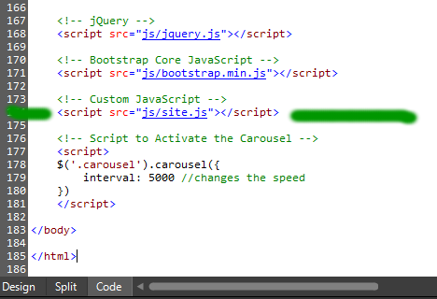

Step 10:
Check the developer console to see if the site.js and site.css files are loading correctly:
Net
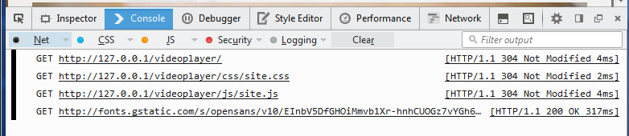
Logging
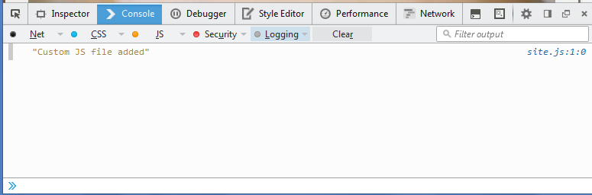

Step 11:
Add the html code to embed a YouTube video on the page
<div class="row">
<div class="box">
<div class="col-lg-12">
<hr>
<h2 class="intro-text text-center">Build a website
<strong>worth visiting</strong>
</h2>
<hr>
<div class="text-center">
<h3 id="title">About The Business</h3>
<iframe id="player" title="Youtube Video Player" width="640" height="390"
src="http://www.youtube.com/embed/iBktYJsJq-E?fs=1&autoplay=0&loop=0"
frameborder="0" allowfullscreen>
</iframe>
</div>
</div>
</div>
</div>

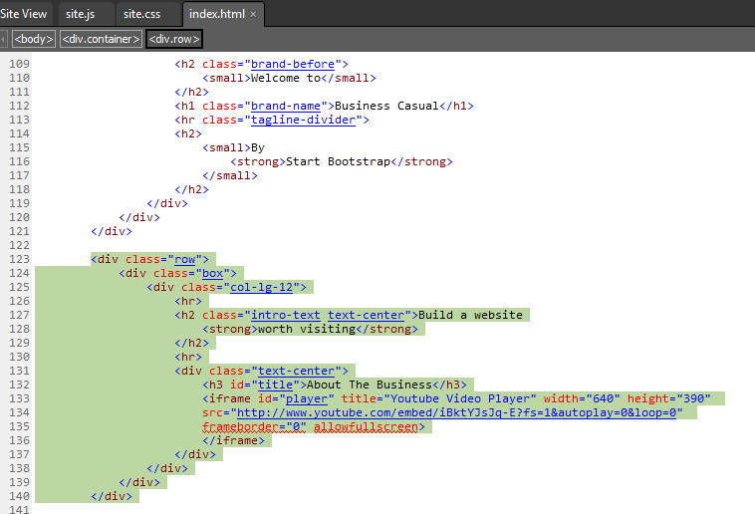
The page should now look as follows:
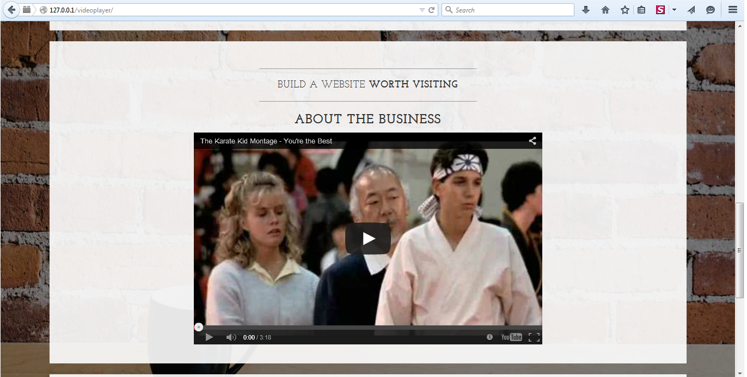

Step 12:
Add a list of videos to the page.
See http://getbootstrap.com/css/ for an overview of how to style and layout the page.
Update the html to look as follows:
<div class="row">
<div class="box">
<div class="col-lg-12">
<hr>
<h2 class="intro-text text-center">Build a website
<strong>worth visiting</strong>
</h2>
<hr>
<div class="text-center">
<h3 id="title">About The Business</h3>
<div class="row">
<div class="col-md-8">
<iframe id="player" title="Youtube Video Player" width="640" height="390"
src="http://www.youtube.com/embed/iBktYJsJq-E?fs=1&autoplay=0&loop=0"
frameborder="0" allowfullscreen>
</iframe>
</div>
<div class="col-md-4">
<h6>Most Popular Videos</h6>
<ul id="videoList" class="list-unstyled">
<li>
<a href="https://www.youtube.com/embed/nIPvk5jwX-8?fs=1&autoplay=0&loop=0">Video 1</a>
</li>
<li>
<a href="https://www.youtube.com/embed/ncDd6X536yg?fs=1&autoplay=0&loop=0">Video 2</a>
</li>
<li><a href="">Video 3</a></li>
<li><a href="">Video 4</a></li>
<li><a href="">Video 5</a></li>
</ul>
</div>
</div>

</div>
</div>
</div>
</div>

Note how Bootstrap is used to add the two columns to the page.
The page should now look as follows:
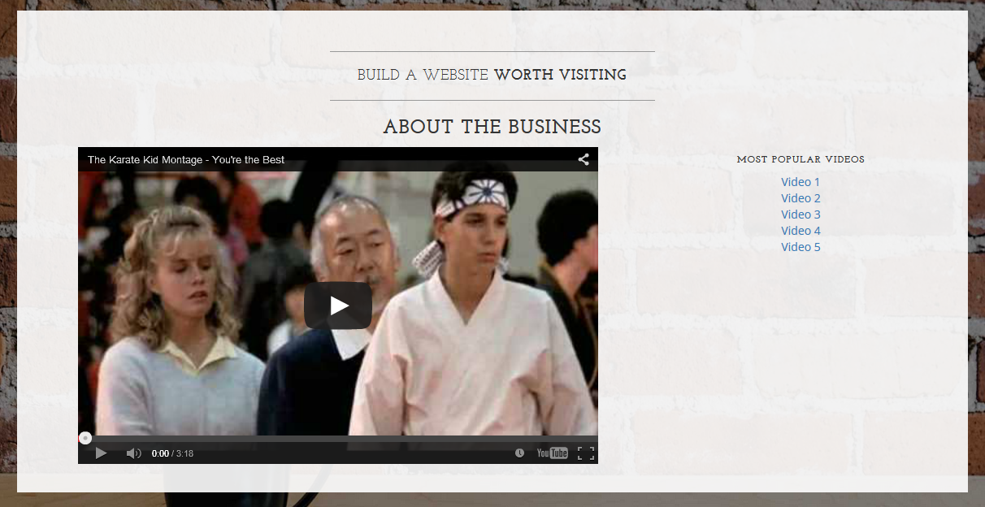
Add the following to the site.js file:
$("#videoList > li > a").on("click", function(e){
e.preventDefault();
// get the url href from the link
var url = $(this).attr("href");
// get a reference to the iframe element on the page
var iframe = $('#player');
// change the src of the iframe to the new video url
iframe.attr('src', url);
});

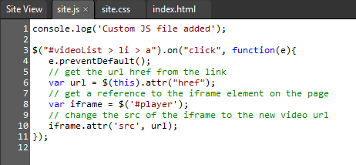

Clicking on Video 1 and Video 2 should change the content of the iframe without leaving the page.
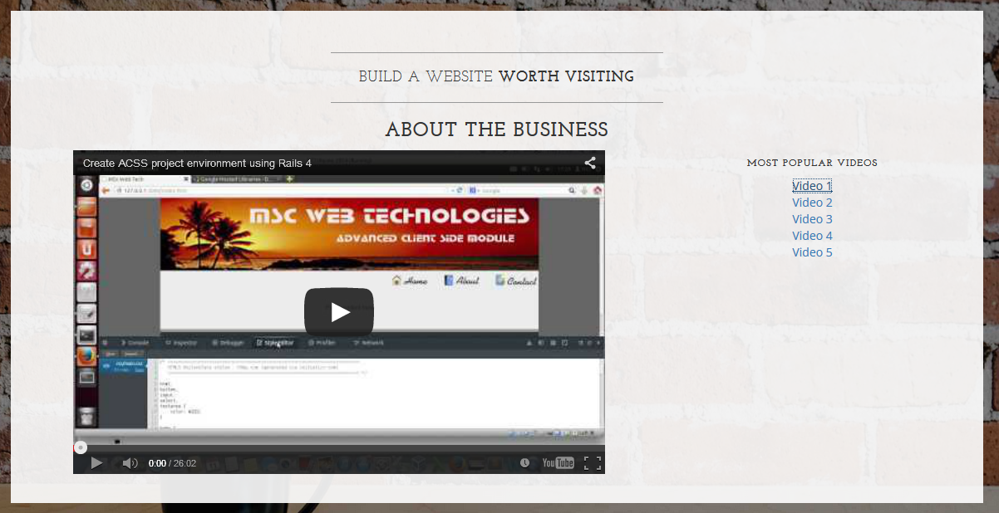

Step 13:
The list of videos will now be stored in an external JSON file.
We will try represent the following information in JSON format.
Video id | url
Video1 | nIPvk5jwX-8
Video2 | RnXgzvzmyng
Video3 | kroOgfX4uZ8
Video4 | ncDd6X536yg
Video5 | Og8fHCdjqU4

Json
{"videos": ["nIPvk5jwX-8","RnXgzvzmyng","kroOgfX4uZ8","ncDd6X536yg","Og8fHCdjqU4"]}
Note: name value pairs. Name is videos, the videos are stored in an array, ie the square brackets.
The video player on the page will change slightly, the list of videos will be dynamically generated and placed on the page. This will be done with an ajax request to get the JSON file, then use JavaScript to create the unordered list for display on the page.

Step 14:
Create a file named videos.js and save it in the js folder.
Add the following JSON to the file:
{"videos": ["nIPvk5jwX-8","RnXgzvzmyng","kroOgfX4uZ8","ncDd6X536yg","Og8fHCdjqU4"]}

Step 15:
Add the following ajax request to the js file.
This will retrieve the json list of videos from the server.
$( document ).ready(function(){
console.log('Custom JS file added 2');
$.ajax({
url: 'js/videos.js',
dataType: "json",
success: function (data) {
genVideoList(data);
},
error: function (e) { console.log('Error - ' + e.responseText); }
});
});

Step 16:
With the JSON data received, we now need to loop through the JSON data and format if for insertion to our unordered list element on the page. Create a new function named genVideoList that accepts a JSON object.
function genVideoList(data) {
console.log('genVideoList');
}
Add this to the site.js file. This does not need to be in the $( document ).ready.
First we need to access the array of videos in the JSON data structure.
var video_array = data.videos;
The variable video_array now stores the array of YouTube videos from the JSON data. This will be looped through to create the list items for the unordered list.
Create a new variable to hold the html list items that will be added to the page:
var html_string = "";
Next step is to loop through the json data and create the html markup for insertion into the page.
for ( var i = 0; i < video_array.length; i++ ) {
var obj = video_array[i];
console.log(obj);
url = "https://www.youtube.com/embed/" + obj + "?fs=1&autoplay=0&loop=0&html5=1";
tmp = "<li><a href='" + url + "'>Video " + (i+1) + "</a></li>";
html_string += tmp;
}
The above for loop will loop through the video_array and create a list item containing a link to the video. Now the markup contained in html_string needs to be added to the page. We will create a function for writing the content to the page.
Create a function named writeContentToPage
function writeContentToPage(id, content) {
$("#" + id).html(content);
}
The id is the id of the element in the page, the content is the content to be written to the page.
Add the following to the genVideoList function to write the html to the page:
writeContentToPage("videoList", html_string);

The two new functions should look as follows:
// ********************** Functions ************************************
function genVideoList(data) {
console.log('genVideoList');
var video_array = data.videos;
var html_string = "";

for(var i = 0; i < video_array.length; i++) {
var obj = video_array[i];
console.log(obj);
url = "https://www.youtube.com/embed/" + obj + "?fs=1&autoplay=0&loop=0&html5=1";
tmp = "<li><a href='" + url + "'>Video " + (i+1) + "</a></li>";
html_string += tmp;
}
writeContentToPage("videoList", html_string);
}

function writeContentToPage(id, content) {
$("#" + id).html(content);
}
// *********************************************************************

Reload the page and try the links, there should be five links on the video player section.
When a video is clicked the page will redirect, why?? The jQuery code we added earlier was used to bind a click event to the links in the list items:
$("#videoList > li > a").on("click", function(e){
e.preventDefault();
// get the url href from the link
var url = $(this).attr("href");
// get a reference to the iframe element on the page
var iframe = $('#player');
// change the src of the iframe to the new video url
iframe.attr('src', url);
});

The event will not bind if the element is not on the page when the script runs.
The code block will need to be run again after we write the html video list markup to the page.
How will we do this? We will create a jQuery function that can be called using the dot notation.

Create a new method as follows:
$.fn.initList = function() {
$("#videoList > li > a").on("click", function(e){
e.preventDefault();
// get the url href from the link
var url = $(this).attr("href");
// get a reference to the iframe element on the page
var iframe = $('#player');
// change the src of the iframe to the new video url
iframe.attr('src', url);
});
}

The $.fn.initList creates a new jQuery function.
The function can be called as follows:
$("#" + id).html(content).initList();

Update the writeContentToPage function to call the initList() function after the html has been written to the page. When functions are called using the dot notation in jQuery the function calls are performed in the order of the dot notation.
function writeContentToPage(id, content) {
$("#" + id).html(content).initList();
}

Reload the page, the dynamic video change on the page should now be working.

Step 17:
In this step we will replace the videos.js JSON data with video data from the YouTube API.
We want to be able to display the 50 most popular trending videos from YouTube.
The following URL will retrieve a list of the most popular videos from the YouTube API:
http://gdata.youtube.com/feeds/api/standardfeeds/most_popular?v=2&alt=json
(Paste this url into a browser to see what the response looks like!!)
This is a complex JSON data structure containing all info regarding a video (eg title, owner comments…..etc..)

Add the following function to the page:
function getYouTubeVideos() {
$.ajax({
url: "http://gdata.youtube.com/feeds/api/standardfeeds/most_popular?v=2&alt=json",
dataType: "jsonp",
success: function (data) { console.log(data); }
});
}

The data type is set as jsonp to allow an ajax request from a source that is not part of our domain.
Add getYouTubeVideos() to the $( document ).ready function.
Comment out the ajax request for the videos.json data
It should now look as follows:

$( document ).ready(function(){
console.log('Custom JS file added 2');
getYouTubeVideos();

/*$.ajax({
url: 'js/videos.js',
dataType: "json",
success: function (data) {
genVideoList(data);
},
error: function (e) { console.log('Error - ' + e.responseText); }
});*/
});

Load the page, you should see the new JSON data from YouTube in the console window.

Step 18:
With the JSON data received from youtube this now needs to be displayed on the page. We will create a function to write the list of videos to the page:

// this function is already in the site.js file!!
function getYouTubeVideos() {
$.ajax({
url: "http://gdata.youtube.com/feeds/api/standardfeeds/most_popular?v=2&alt=json",
dataType: "jsonp",
success: function (data) { showMyVideos(data); }
});
}

function showMyVideos(data) {
var feed = data.feed;
var entries = feed.entry || [];
var html = [""];
for (var i = 0; i < entries.length; i++) {
var entry = entries[i];
var title = entry.title.$t;
var id = entries[i].id.$t.split('/').reverse()[0];
var playerUrl = entries[i].media$group.media$content[0].url + '&fs=1&autoplay=0&loop=0';
html.push("<li><a href='", playerUrl, "'>", title, "</a></li>");
}
$("#videoList").html(html.join('')).changeVideo();
}

Note the change to the getYouTubeVideos function. We already added this to the page, we just need to update it to call the showMyVideos(data) function.

Reload the page, the video player should look as follows:
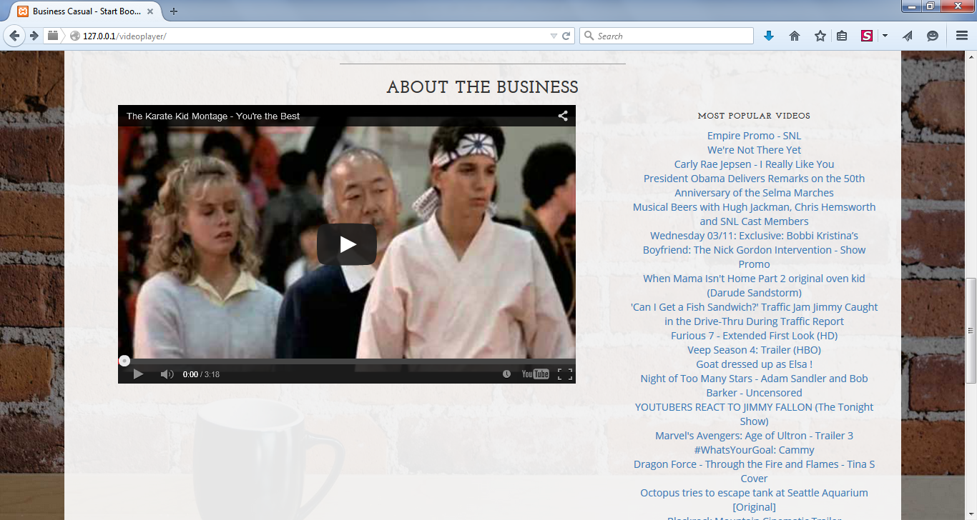

The list of videos is now coming from the YouTube API
Click one of the links, the page redirects to the video, why?
The on click event is not being bould to the list items as they are being dynamically loaded after the page has loaded. We will create a jQuery function to rectify this!!

Step 19:
Add the following to the site.js file.
$.fn.changeVideo = function() {
$("#videoList > li > a").on("click", function(e){
e.preventDefault();
//alert("I was clicked");
var url = $(this).attr("href");
var iframe = $('#player');
iframe.attr('src', url);
//getYouTubeInfo(url);
});
};
Make sure the last line of the showMyVideos function liiks as follows:
$("#videoList").html(html.join('')).changeVideo();
The new jQuery function changeVideo is called through the dot notation.

Reload the page, the videos should change when clicked without leaving the page.

Additional Tasks
- An intentional bug has been left in the application that occurs when the video is loaded in the iframe. See if you can use the developer console and online resources to resolve the issue.
- Try use css to style the video links on the page to look better.
- Add a label to the page to inform the user that the video has changed. This should be above the iframe and should display for 5 seconds then fade away.
- Try add a fade in for the iframe video change.
- Try use the YouTube API to display the video info on the page (The following code has been provided as a start!!):
function getYouTubeInfo(newURL) {
$.ajax({
url: newURL,
dataType: "jsonp",
success: function (data) { parseresults(data); }
});
}

function parseresults(data) {
var title = data.entry.title.$t;
var description = data.entry.media$group.media$description.$t;
var viewcount = data.entry.yt$statistics.viewCount;
var author = data.entry.author[0].name.$t;
$('#title').html(title);
$('#description').html('<b>Description</b>: ' + description);
$('#extrainfo').html('<b>Author</b>: ' + author + '<br/><b>Views</b>: ' + viewcount);
getComments(data.entry.gd$comments.gd$feedLink.href + '&max-results=50&alt=json', 1);
}

<div id="description">Could not find a description</div>
<div id="extrainfo">Could not find extra information</div>
<div id="comments">Could not find comments</div>

Make sure the jQuery changeVideo function calls the getYouTubeInfo(url);
Hint: it is currently commented out!!

